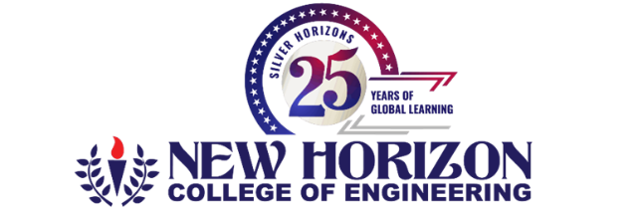

Claim Form 4
Department of Research and Development
(Ref: Research Promotion Policy for the AY 2025-26 - Category 2: Research R&D Projects)
S. No | Parameter | Details
 | Name of the Faculty PI
 | Designation
 | Department
 | Name(s) of Co-PI and their details if any
 | Category | Sponsored Research Projects / Funded - Seminar / Workshop / Conferences / STTP
 | Title of the Work
 | Scheme of Funding
 | Funding Agency
 | Sanctioned File No. (as per the order)
 | Duration of the work
 | Whether infrastructure of institution is used for execution of the work | Yes / No
 | Total Amount Sanctioned
 | Total Amount Released
*** Please attach necessary documents

Incentive for Research Grant will be as below:
Research Grants | Organizing Funded seminar / conferences / workshops / STTP
- PI will get 10% of the sanctioned amount if there is no Co-PI  - PI will get 7% of the sanctioned amount and Co-PI will share 3% | - The breakup of 10% Financia; incentives – 9% for PI and Co-PI (7% for PI and 2% for Co-PI), 1% for HoD  - If no Co-PI then 9% for PI only, 1% for HoD

- Incentives will be released to PI & Co-PI after the release of sanctioned amount.
- 100% of the incentives will be released after completion of the project and submission of the Utilization Certificate / getting NoC / project closure from the concerned authority

PI / CO-PI HOD Associate Head - R&D (Grants)

DEAN R&D EXE.DIRECTOR-HR PRINCIPAL SR.EXE.DIRECTOR FINANCE & ACCOUNTS

Date:

